St. Francis Institute of Technology, Mumbai-400 103

**Department Of Information Technology**

A.Y. 2024-2025

Class: TE-ITA/B, Semester: V

Subject: **DevOps Lab**

**Experiment – 10: To learn Pull based Software Configuration Management and provisioning tools using Puppet.**

1. **Aim:** To install and Configure Pull based Software Configuration Management and provisioning tools using Puppet.
2. **Objectives:** Aim of this experiment is that, the students will learn:

* To Synthesize software configuration and provisioning using Puppet
* To Build and operate a scalable automation system.

1. **Outcomes:** After study of this experiment, the students will learn following:

* Architecture of Puppet
* Puppet Master Slave Communication
* Configuring Puppet Master and Agent on Linux machines

1. **Prerequisite:** None
2. **Requirements:** AWS account,putty, Personal Computer, Windows operating system, Internet Connection, Microsoft Word.
3. **Pre-Experiment Exercise:**

**Brief Theory:** Refer shared material

1. **Laboratory Exercise**
   * + 1. **Procedure:**

**a. Answer the following:**

* What is Puppet? Enlist its features.

Puppet is an open-source configuration management tool designed to automate the deployment, configuration, and management of software and systems. It enables system administrators to define the desired state of their infrastructure as code, ensuring consistency and reducing manual effort. Puppet uses a declarative language to describe system configurations, allowing for automated provisioning and orchestration.

### Key Features of Puppet

* **Declarative Language:**Uses a high-level, declarative language to define system configurations, making it easier to manage complex infrastructures.
* **Idempotency:**Ensures that applying the same configuration multiple times will produce the same result, preventing unintended changes.
* **Cross-Platform Support:**Works across various operating systems, including Linux, Windows, and macOS, enabling management of heterogeneous environments.
* **Extensible Modules:**Offers a rich library of pre-built modules that can be easily reused, allowing for rapid deployment of applications and services.
* **Infrastructure as Code:**Allows configuration files to be version-controlled, promoting collaboration and reducing errors.
* Explain architecture of Puppet with a diagram.

Puppet Master-Slave Architecture

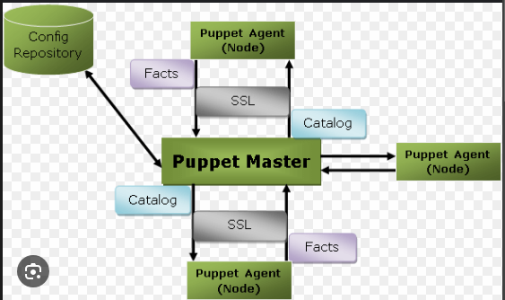

Puppet’s architecture consists of several components that work together to enable configuration management and automation. Here’s a brief overview of its main components:

1. **Puppet Master (Server):**The central server that holds the Puppet manifests (configuration files). It compiles the configurations based on the manifests and sends them to the agents.
2. **Puppet Agent:**Installed on the managed nodes (clients). The agent periodically checks in with the Puppet master to retrieve and apply the configurations.
3. **PuppetDB:**An optional database that stores information about the state of the infrastructure and the resources managed by Puppet. It enables reporting and querying of data.
4. **Puppet Forge:**A repository of community-contributed modules that can be used to extend Puppet’s capabilities.
5. **Hiera:**A key/value lookup tool for configuration data, allowing for hierarchical data storage and retrieval, which helps in managing complex configurations.
6. **Console:**A web-based user interface for managing Puppet environments, visualizing configurations, and reporting.

**b**. **Refer the shared material and do online research to answer following:**

i. Mention steps for creating 2 EC2 instances with Ubuntu OS on AWS for creating master and slave machines. Attach screenshots for the same.

ii. Commands used to configure master and slave machines using putty.

**Commands to run on puppet Master (which is one of the EC2 instances)**

* sudo apt-get update :This command will update the packages
* wget <https://apt.puppetlabs.com/puppet-release-bionic.deb> :This command will download the puppet folder
* sudo dpkg -i puppet-release-bionic.deb :This command will unzip the puppet folder
* sudo apt-get install puppetmaster : This command will install the puppet master
* apt policy puppetmaster : This command will verify puppet master after installation
* sudo systemctl status puppet-master.service: This command will check status of puppet master service
* sudo nano /etc/default/puppet-master: This command will fine tune some settings….
* Add this line in the puppet master file: JAVA_ARGS=“-Xms512m - Xmx512m”

This command will change the memory allocation to 512MB

* sudo systemctl restart puppet-master.service : This command will restart puppet master after the recent changes
* sudo ufw allow 8140/tcp : This command will open TCP port for puppet to communicate
* sudo nano /etc/hosts : This command will open hosts file for entering master’s IP address
* sudo puppet cert list : This command will show puppet agent’s certificate received for signing
* sudo puppet cert sign –all : This command will sign the received certificate

**Commands to run on slave node/ puppet agent (which is the other EC2 instance)**

* sudo apt-get update: This command will update the packages
* wget <https://apt.puppetlabs.com/puppet-release-bionic.deb> This command will download the puppet folder
* sudo dpkg -i puppet-release-bionic.deb :This command will unzip the puppet folder
* sudo apt-get install puppet :This command will install the puppet agent
* sudo nano /etc/hosts :This command will open hosts file for entering master’s IP address
* sudo systemctl start puppet :This command will start the puppet agent
* sudo systemctl enable puppet :This command will enable the puppet agent
* sudo puppet agent --test :This command will test communication between puppet master

1. **Post-Experiments Exercise**
2. **Extended Theory:**

Nil

1. **Questions:**

* Explain the two types of configuration management approaches.
* How does the connection between puppet master server and puppet agent nodes happen?

1. **Conclusion:**

* Write what was performed in the experiment.
* Write the significance of the topic studied in the experiment.

1. **References:**

<https://www.edureka.co/blog/puppet-tutorial/>

<https://www.simplilearn.com/puppet-tutorial-article>

STEPS FOR CREATING EC2 INSTANCES

master instance:

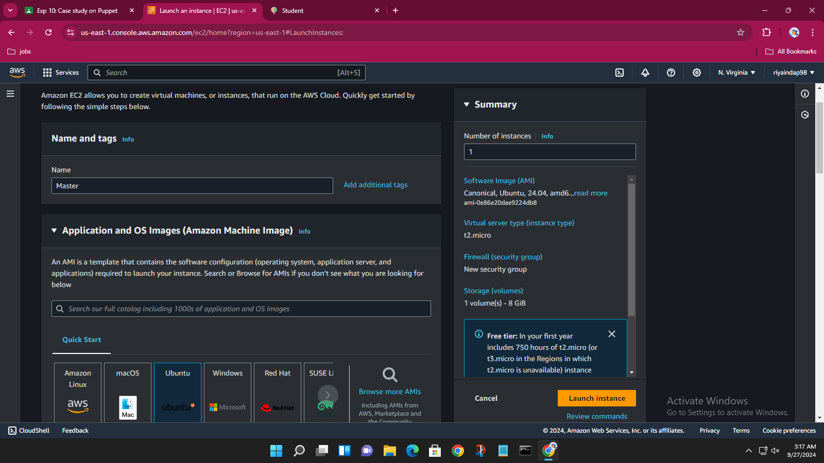

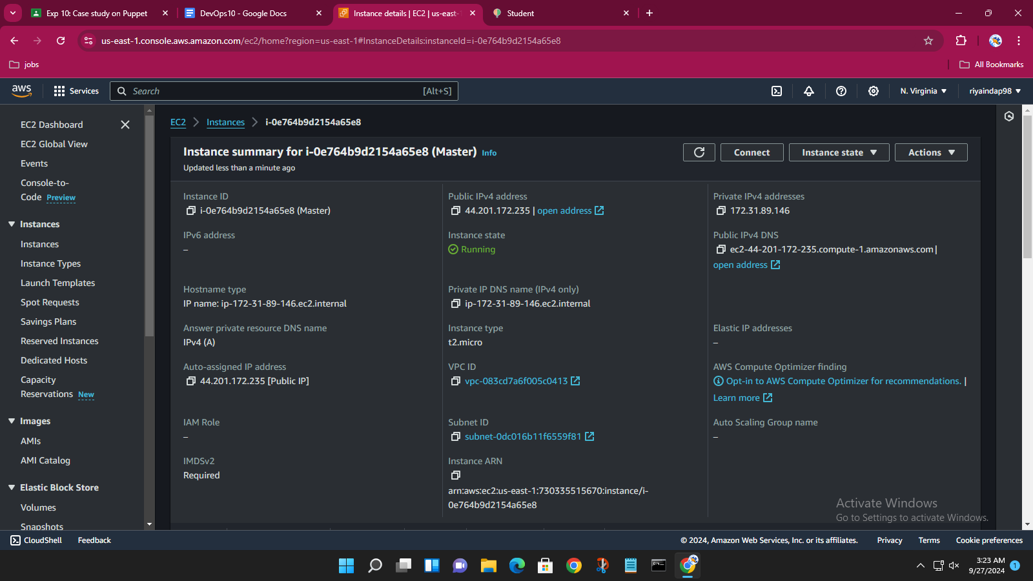

Slave instance:

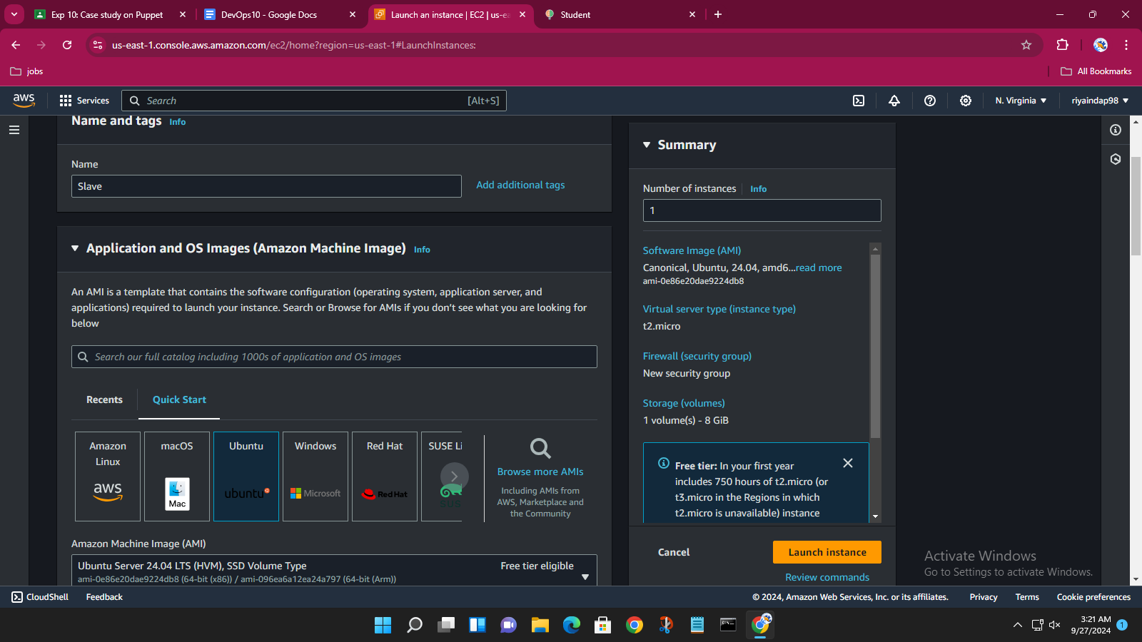

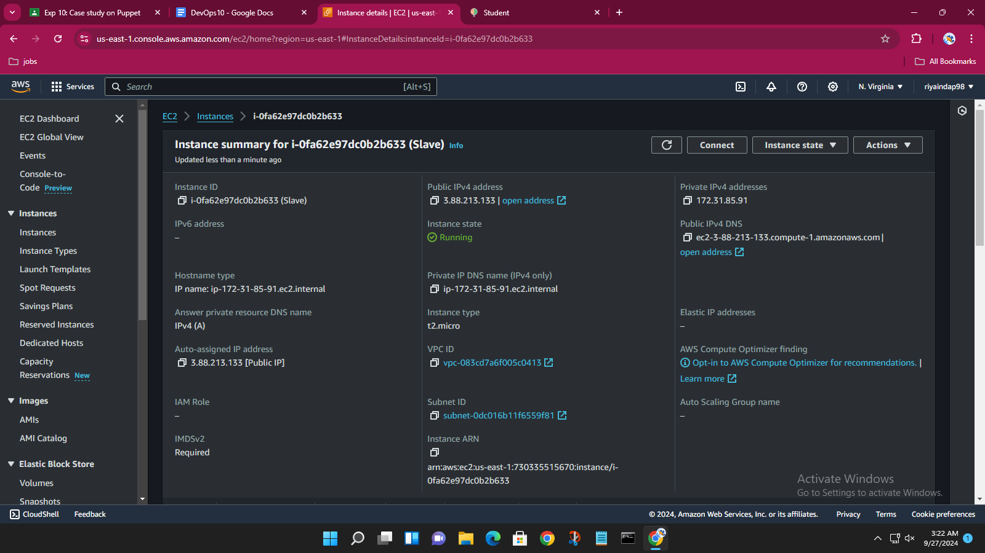

The created instances:

